Crispy Nuggets & Spicy Stew
Inspired by


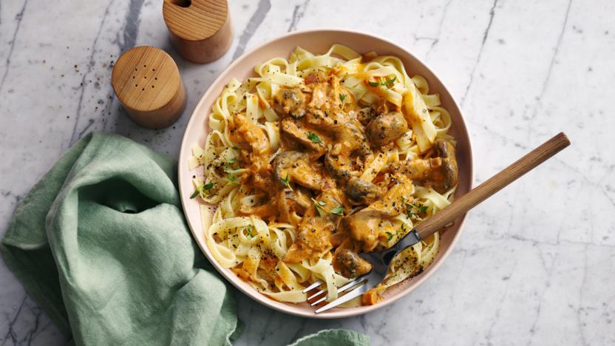
DID YOU KNOW?
“Cauliflowers contain the best source of choline, which is renowned for brain and memory development. Remember to eat these and you won’t forget a thing!”

Nutrition – Total / Per Serving
Calories: ??kcal / ??kcal
Carbohydrates: ??g / 150g
Protein: ?g / 40g
Fat: ?g / 30g
Fibre: ?g / 2g
Sugar: ?g / 1.5g
Ingredients
1 cauliflower
3 tbsp mayonnaise
100g breadcrumbs
1 tbsp + 1 tsp of Cajun seasoning
1 onion
2 portobello mushrooms
4 cloves of garlic
½ tsp chili powder
1 tin of chopped tomatoes
1 tin of butter beans
1 tbsp olive oil
75ml of water
1 vegetable stock paste






Good for:

Star Rating:





Method

Step 1 – Prep your Cauliflower
Preheat your oven to 220°C.
Cut your cauliflower into slightly bigger than bite size florets.
Place them into a mixing bowl together with salt and pepper and the mayonnaise. Coat the cauliflower.
In another bowl, mix together the breadcrumbs, 1 tbsp of Cajun seasoning, and olive oil. Add the breadcrumb mix to the bowl with the cauliflower, toss to coat.

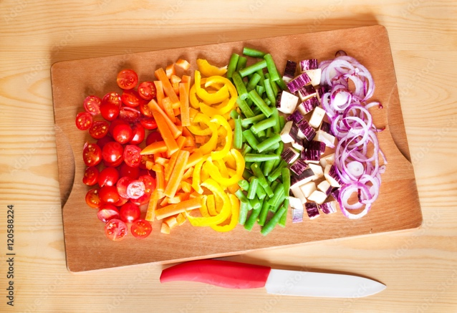
Step 2 – Crisp & Prep
Place the cauliflower nuggets onto a baking tray, spread into a single layer and put the tray into the oven.
Roast in the oven until golden (~25-30min).

In the meantime, dice the onion and garlic. Quarter the portobello mushrooms.
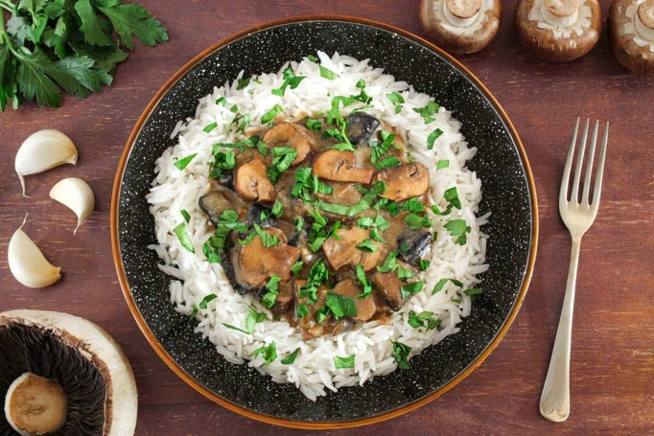
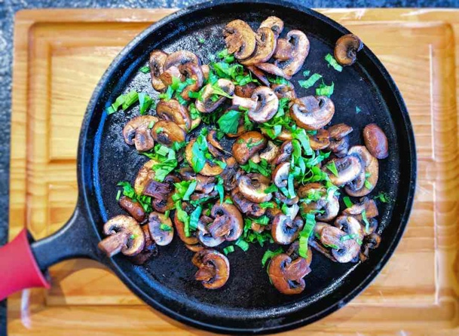
Step 3 – Simmer your stew
Heat a saucepan with a drizzle of oil. Add the onion and fry until golden (~4 min).
Stir in the portobello mushrooms, garlic and 1 tsp of Cajun seasoning, cook for another minute.
Add in the chopped tomatoes, vegetable stock paste and water.
Bring the stew to a simmer, then lower the heat and allow to simmer until thickened (~5 minutes).

Drain and rinse the butter beans, put 2/3 of them straight into the saucepan, crush the remaining 1/3 before placing them into the saucepan as well. Cook for another ~5 minutes until thickened.

Step 4 – Bring it Together
Add chili to the saucepan, mix well.
Then remove the saucepan from the heat.
Once the nuggets are crispy, remove them from the oven.
Serve the spicy bean stew into bowls before adding the cauliflower nuggets on top.

Enjoy!

